Annual Returns Help and Guidance


Contents
First Use 4
Registering 4
Logging In 5
Password problems 5
Home Screen 5
Using the site 6
Navigation 6
Select Your Role 6
Main Page – Circuit Users 6
Main Page – District Users 7
Church Return 8
Outline 8
Important Note Regarding LEPs 9
Completing the Return 9
Paper Copy 9
Online Copy 9
Property 9
Documents 10
Insurance 10
Safeguarding 10
Finance 10
General Administration 10
Carbon Footprint 10
Sign off 11
Circuit Return 12
Completing the return 12
Property 12
Documents 12
Insurance 13
Safeguarding 13
Finance 13
General Administration 13
Sign off 13
District Returns 14
Completing the return 14
Property 14
Documents 14
Insurance 15
Safeguarding 15
Finance 15
General Administration 15
Sign off 15
Reports 16
Contacts 17

First Use
The Annual Returns site was launched in 2013 as a replacement to Schedules A, C and D. Doing so means that the collected data can be more easily viewed by the Circuit and District and will also mean less repetition of information for the managing trustees.
Once all the data has been collected, then the Circuit and District will be able to generate reports on certain aspects of the return, making it far easier to spot any potential issues. There is no national scrutiny of the annual returns they are intended purely as a check-list to help circuits and districts.

Registering
If you have never used the Online system before, such as the Statistics for Mission or Property Consents sites, then you will need to register.
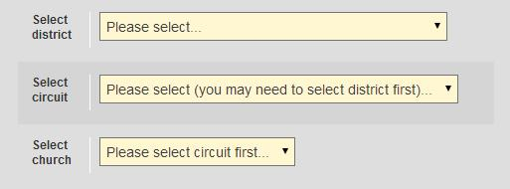
To register, click on the button that says Register and fill out the form. The details you will need to enter will be marked with an asterisk (*). Once you have filled out the address section, you will be asked to select your District, Circuit and Church, in that order. If you only require District or Circuit permissions, then leave the church blank.

If you are seeking permissions for more than one church, then you will need to speak to your Superintendent who will be able to add additional churches on to your account.
When you have successfully registered, you will receive an email containing your password. You will not be able to access the site however until your Superintendent has authorised your account. You will be notified in another email when this has happened. If you do not receive an authorisation you may need to contact your Superintendent to remind them.

Logging In
Once you have registered and been authorised, you will then be able to log in by entering the email address you registered with in to the box where it says Email and the password will need to go in to the box that says Password.

Password problems
If you can’t remember your password, you can request a new password by clicking on Forgotten Your Password? This will ask you to enter your email address at which point an email will be sent to you with a link to Reset your password. Click on that link and another email will then be sent to you with a randomly generated password of 8 characters and numbers (it will look something like this: Au65bx2f)
If you haven’t received either of these emails, firstly check that you entered your email address in correctly. If you are sure your email address is correct, then check your spam/bin folders in your email account as on rare occasions it will end up in there.
If you are still having trouble, contact the Methodist Church Helpdesk on 020 7486 5502 who will be able to help you.

Home Screen
When you have successfully logged in you will be taken to the Home Screen with options to go to the Property Consents, Statistics for Mission and Property Returns site. If you have user management permissions, you will also see a Manage Users section too.

Using the site

Navigation

Select Your Role
If you have more than one role, you will be asked to select which one you wish to use for completing the return. You can change roles at any time by clicking on the “Role:” display in the top right hand corner.
The effect of the different roles is outlined below:
Church Trustee – This role will allow you to view and edit the local church returns for those that you have permission for.
Circuit Trustee – The Circuit Trustee role allows you to view all church returns within the circuit as well as completing the Circuit Return (see Circuit Return for further information). You can also view reports on any issues that churches may have through the Property Issue Summaries.
District – As a District user, you will be able to see the returns of all the churches and circuits within your district, as well as completing the District Return. You can also view reports on any issues that churches may have through the Property Issue Summaries.
If you find that you cannot edit a return, first make sure you are logged in as the correct role (circuit trustees cannot edit church returns for example) and if that does not resolve the issue, contact your superintendent (for churches) or district property secretary (for circuits) to make sure that Update permissions have been set.

Main Page – Circuit Users
This page will give you a list of all the churches within your circuit. The column headings will give you further information about each church.
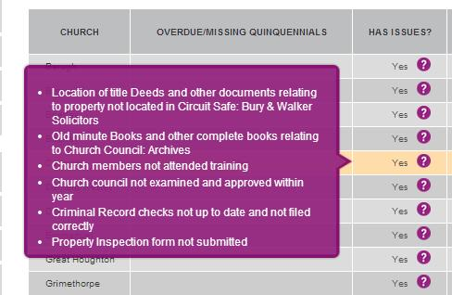
Church – This is the name of the church
Overdue/Missing Quinquennial – This identifies whether the church has either an overdue quinquennial report or missing one entirely.
Has Issues? – This identifies whether a church has any issues based on the answers within the return. You can find out which sections have issues by moving your mouse cursor over the purple questions mark. This does not necessarily mean that there is a problem, but just that it’s worth looking at.
Return Completed? – This identifies which churches have completed their return.
Option – This will allow you to view the return for a particular church. Please note, you will not be able to edit the return.
On the left hand side of the page you will see a sidebar that will assist you in navigating the site. This allows you to filter for particular churches or issues as well as generating reports.

Main Page – District Users
This page lists all the circuits within your district, as well as giving information on how many churches and circuits have completed their returns. The column headings will give you more information about each circuit:
Circuit – This is simply the name of the circuit.
Church Returns – This tells you how many churches within that circuit have completed their returns.
Circuit Return Completed? – This lets you know if that circuit has completed their circuit return.

Select Your Role
If you have more than one role, you will be asked to select which one you wish to use for completing the return. The roles are outlined below:
Church Trustee – This role will allow you to view and edit the local church returns for those that you have permission for.
Circuit Trustee – The Circuit Trustee role allows you to view all church returns within the circuit as well as completing the Circuit Return (see Circuit Return for further information). You can also view reports on any issues that churches may have through the Property Issue Summaries.
District – As a District user, you will be able to see the returns of all the churches and circuits within your district, as well as completing the District Return. You can also view reports on any issues that churches may have through the Property Issue Summaries.
Option – This gives you the option of either viewing the circuit return or viewing the list of churches within that circuit (see Main Page – Circuit Users for more information)
The sidebar here acts in the same way as the circuit sidebar, allowing you to filter for particular circuits, churches or issues, as well as generating reports based on the information provided within the returns.

Church Return
As a church trustee, you will be expected to complete and submit a return against the churches you are responsible for. To help you with this, we have created an online form for you to complete (if you have difficulty accessing the internet, then you can download a paper copy, more info can be found under Paper Copy)
If your church has closed, please read the document on How to report a church closure for further instruction

Outline
The return itself is split up into separate tabs, each one representing a different area of responsibility. When a tab has been completed, it will turn green. Incomplete tabs will be amber.
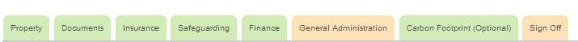
In the above example, you can see that all the tabs except General Administration and Sign Off have been completed

Once all the tabs (except Sign Off) have been completed and turned green, you will be able to complete the return. More information can be found under Sign Off.
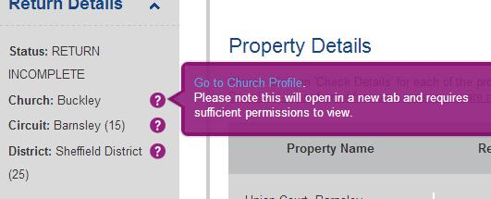
The sidebar will give you basic information about the return, such as its status (complete or incomplete), the name of the church, circuit and district with links to the relevant profiles on the Statistics for Mission website.
You can also take a print out of the return as it stands by clicking on Church Return under Print Reports.

Non-Model Trust Property, including non-Methodist owned LEP property
There may be property on the return that does not belong to the Methodist church, as it is owned by another denomination, or may not be on model trust. These properties do require a return. However, from this year, we have made it so the return does not ask certain questions against these properties. For example, if your property is not on model trusts, you will not be asked questions about the quinquennial inspection report.
We hope that this will make the return easier to complete.

Completing the Return
There are two ways of completing the return; by completing the online form or by printing off a paper copy and completing it by hand. If you need to complete it by hand, you will have to hand it back to someone to copy on to the online system for submission.

Paper Copy
To obtain a paper copy, click on Download paper form if for some reason you are not able to complete online. You can then print this off and complete by hand. This will need to be handed back to someone to submit online as paper submissions are no longer accepted.

Online Copy
As already mentioned, the online return is split up into separate tabs, each representing a different responsibility.

Property
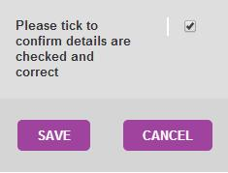
The Property tab will be the first tab you see and has two main sections to it. One is the associated property details, for example the chapel and caretakers cottage will be listed separately and the other is against the properties as a whole, such as repair budgets for the sites.
The Check Details section has its own list of questions, relating to the address and general state of the building. Once all the fields have been completed, you will need to tick the box at the bottom of the page that says Please tick to confirm details checked and correct.
You will need to do this for each property. Once all the properties listed have a Y next to them under Return Completed then you will be able to complete the rest of the Property tab.

Documents
The documents tab is about making sure you have a record of where critical documents are kept. You will be given the option of saying whether the documents are kept in a local safe, circuit safe or other location, which will need to be defined.

Insurance
The insurance tab will show you a list of the properties against the church and the latest insurance details that we have. If these are blank or need updating, click Update Details.
The other questions relate to any new risk and to ensure that premiums are paid and up to date.

Safeguarding
The safeguarding tab is there to ensure that all churches are following the safeguarding practices in law and standing orders. If you are an LEP, you will need to find out whose Safeguarding policy you are using and complete the form accordingly.
If you are unsure about anything in this section, please contact your Circuit or District Safeguarding Officer.

Finance
This tab is there to compliment the information entered in the Standard Form of Accounts. You will need to have had audited the previous year’s accounts as well as have a good idea of the financial situation within your circuit. It is strongly recommended that the treasurer feeds in to this section.

General Administration
This section will cover the miscellaneous bits of the day to day work within a church as well some of the legal aspects such as rights of way and associated leases.

Carbon Footprint
This tab is optional. The purpose of this tab is to collect information about the energy consumption of churches. This relates to the work around the Hope in God’s Future project.
For the purposes of this tab, we are only collecting information against gas and electricity meters.
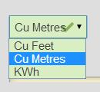
If your church has more than one meter, please enter the total consumption figures. For electricity, this will need to be in Kilowatt-hours (KWh), whereas for gas you will have the option of entering this in as Cubic Feet, Cubic Meters or kWh.
To make sure that your church can provide a consistent reading for this project, you will need to take the reading at the same time every year.

Sign off
Once all the other tabs have been completed (indicated by them all being green), you will be able to sign off the return.
If you want to make any additional comments for your superintendent or district property secretary to read, you can do so here.
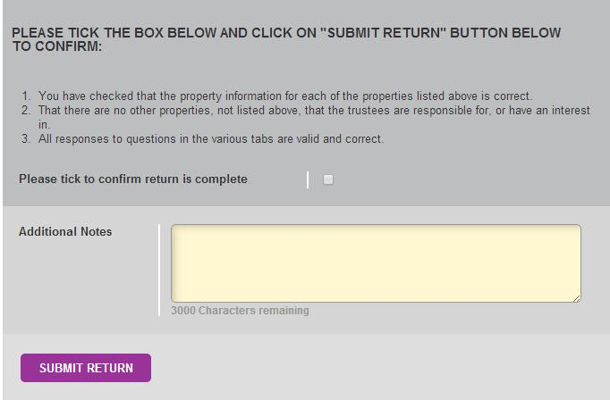

Circuit Return
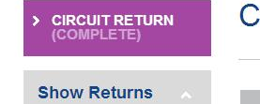
The circuit return contains questions relating to the circuit responsibilities, including manses and churches where the circuit have become the managing trustees. To access the circuit return, you will need to click on Circuit Return in the top left hand corner of the screen.
You will need to have Circuit permissions to complete the return. If you have multiple roles, i.e. District, Circuit and Church, you will need to make sure you select Circuit to access the returns.
As with the Church return, you can print off a copy for completion by hand. This will need to be handed back to someone to copy and submit on to the online system. Further information can be found under Paper Copy.

Completing the return
The circuit return looks a lot like the church return, however there are a couple of differences; mainly that there are usually a lot more properties associated with the circuit than a church and that the Carbon Footprint tab is not required for circuit property, so therefore does not appear.

Property
The Property tab will be the first tab you see and has two main sections to it. One is the associated property details, for example the manses and other circuit property will be listed separately and the other is against the properties as a whole, such as repair budgets for the sites.
The Check Details section has its own list of questions, relating to the address and general state of the building. Once all the fields have been completed, you will need to tick the box at the bottom of the page that says Please tick to confirm details checked and correct.
You will need to do this for each property. Once all the properties listed have a Y next to them under Return Completed then you will be able to complete the rest of the Property tab.

Documents
The circuit documents tab has some differences from the church one, in that only the title deeds and old minute books need to be recorded.

Insurance
The insurance tab will show you a list of the properties against the circuit and the latest insurance details that we have. If these are blank or need updating, click Update Details.
The other questions relate to any new risk and to ensure that premiums are paid and up to date.

Safeguarding
The safeguarding tab is there to ensure that all properties are following the safeguarding practices in law and standing orders. If manses are also used as a place of work, i.e. a separate office within the manse, then the safeguarding policy is required. You should treat this section as an exception report, rather than trying to answer for individual properties.
If you are unsure about anything in this section, please contact your District Safeguarding Officer.

Finance
This tab is there to compliment the information entered in the Standard Form of Accounts. You will need to have had audited the previous year’s accounts as well as have a good idea of the financial situation within your circuit. It is strongly recommended that the treasurer feeds in to this section.

General Administration
This section will cover the miscellaneous bits of the day to day work within the circuit as well some of the legal aspects such as rights of way and associated leases. Again, this tab should be treated as an exception report, rather than for individual properties.

Sign off
Once all the other tabs have been completed (indicated by them all being green), you will be able to sign off the return.
If you want to make any additional comments for your district property secretary to read, you can do so here.

District Returns
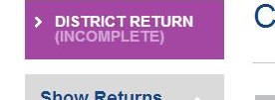
The District return relates to all property where the district are the managing trustees, such as the chair’s manse. To access the district return, you will need to click on District Return in the top left hand corner of the screen.
You will need to have District permissions to complete the return. If you have multiple roles, i.e. District, Circuit and Church, you will need to make sure you select District to access the returns.
As with the Church return, you can print off a copy for completion by hand. This will need to be handed back to someone to copy and submit on to the online system. Further information can be found under Paper Copy.

Completing the return
The district return looks a lot like the church return, however there are a couple of differences; mainly that there are usually more properties associated with the district than a church and that the Carbon Footprint tab is not required for district property, so therefore does not appear.

Property
The Property tab will be the first tab you see and it has two main sections to it. One is the associated property details, for example the manses and other district property will be listed separately and the other is against the properties as a whole, such as repair budgets for the sites.
The Check Details section has its own list of questions, relating to the address and general state of the building. Once all the fields have been completed, you will need to tick the box at the bottom of the page that says Please tick to confirm details checked and correct.
You will need to do this for each property. Once all the properties listed have a Y next to them under Return Completed then you will be able to complete the rest of the Property tab.

Documents
The district documents tab has some differences from the church one, in that only the title deeds and old minute books need to be recorded.

Insurance
The insurance tab will show you a list of the properties against the district and the latest insurance details that we have. If these are blank or need updating, click Update Details.
The other questions relate to any new risk and to ensure that premiums are paid and up to date.

Safeguarding
The safeguarding tab is there to ensure that all properties are following the safeguarding practices in law and standing orders. If manses are also used as a place of work, i.e. a separate office within the manse, then the safeguarding policy is required. You should treat this section as an exception report, rather than trying to answer for individual properties.
If you are unsure about anything in this section, please contact your District Safeguarding Officer.

Finance
This tab is there to compliment the information entered in the Standard Form of Accounts. You will need to have had audited the previous year’s accounts as well as have a good idea of the financial situation within your district. It is strongly recommended that the treasurer feeds in to this section.

General Administration
This section will cover the miscellaneous bits of the day to day work within the district as well some of the legal aspects such as rights of way and associated leases. Again, this tab should be treated as an exception report, rather than for individual properties.

Sign off
Once all the other tabs have been completed (indicated by them all being green), you will be able to sign off the return.
If you want to make any additional comments for your district property secretary to read, you can do so here.

Reports
Once the returns have been completed, the circuit and district will be able to start generating reports against the churches.
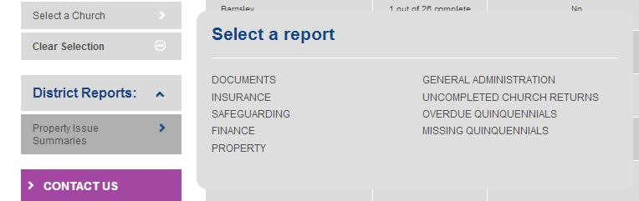
The Reports can be found under Circuit/District Reports by clicking on Property Issue Summaries. This will bring up a menu of different options, relating to each section within the return.

If you want to easily find out which church has particular issues, hover over the purple question mark next to a particular church and it will tell you where the issues lie.
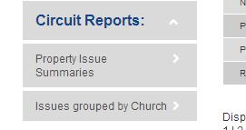
The Circuit will also be able to generate a report which groups the issues by church. This will help form a more specific church report of any potential issues. This is located just under Circuit Reports.

Church Reports
You can now print off reports for previous years on the church return page, as well as a report on all property associated with a particular church.

Church Return
You can access previous return submissions going back to 2013. To access these:
- Go to the church return.

- Go down to Print Reports

- Click on Church Return

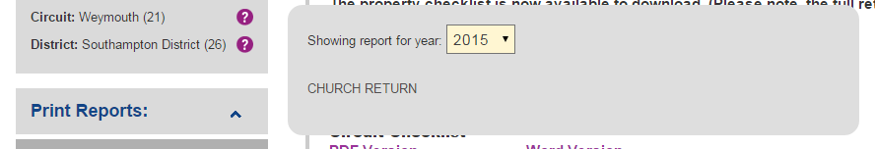
- Select the year you wish to see the report for

- Click Church Return.

- A PDF will now start downloading. This will contain the information entered for that year’s return.

Property Information Reports
To access a report on the property associated with a particular church, follow these steps:
- Go to the church return with which the property is associated.

- On the left hand side, look for Print Reports

- Click on Property Information

- A PDF document will then start to download. Open this up to see all the property information, such as address, date of last quinquennial and any restrictive covenants against the property.

Contacts
If you have any questions regarding the return, firstly, please contact the person responsible for that information, e.g. safeguarding officer for questions on safeguarding.
Alternatively, please email returns@methodistchurch.org.uk for general assistance with the returns.
If you are still having issues, please contact the Methodist Church Helpdesk who will be able to assist you or put you through to someone who can help.
Methodist Church Helpdesk:
Tel: 020 7486 5502
email: helpdesk@methodistchurch.org.uk

